1. Name (Project heading) : YOGA TUTORIAL

2. Remote Centre ID (RC_ID) : 1079

3. College / Institute Name : Geeta Institute Of Management and

Technology, Kanipla

4. City, State, Pin Code : Kurukshetra ,Haryana, 136118

5. Name/’s of the Student : Shivani Singal, Team Members: Snigdha , Vishavraj Munjal.

6. About (Short Description / Summary): The Yoga Tutorial is an application in which we can get the information about different asanas , that is,

* How can we do the particular asana
* Steps followed to do the particular asana
* What are the fruits of that asana
* And also precautions followed regarding that asana
* It has both the facility to read the text or also can see the video for how to the particular asana.

In this application we also get information about history of YOGA, and it’s benefits.

This application has facility to know about the asana which we can do in particular disease in order to cure it.

8. Usage (add instruction on how to use the app, or you can redirect to

External link if you have one):-

**ICON PAGE**

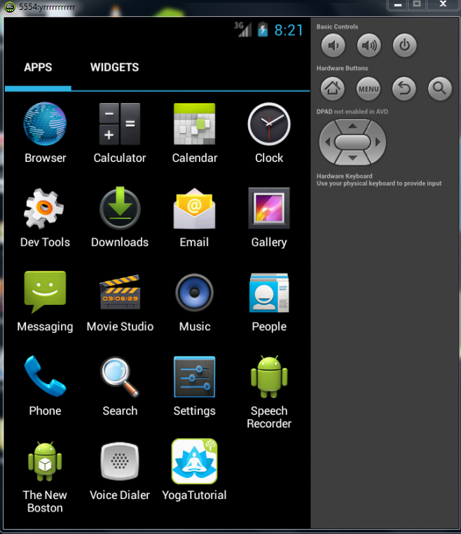

**LOADING PAGE**

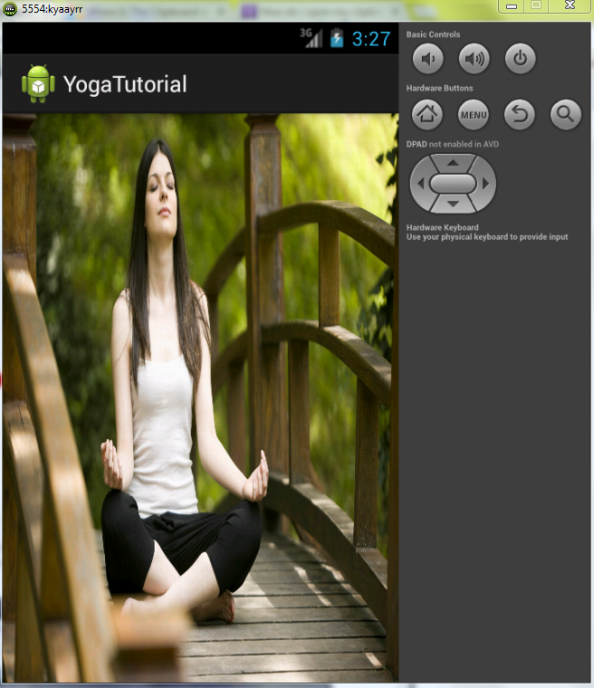

**FIRST ACTIVITY**

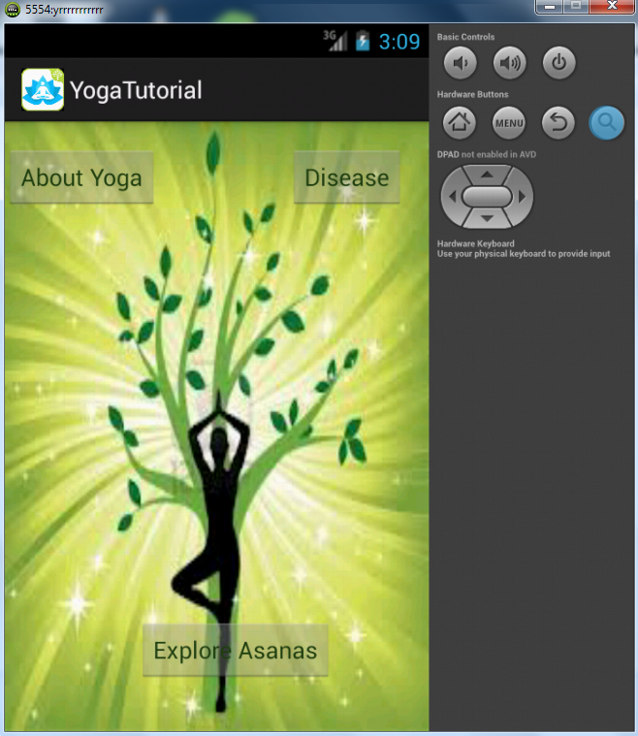

**ABOUT YOGA**

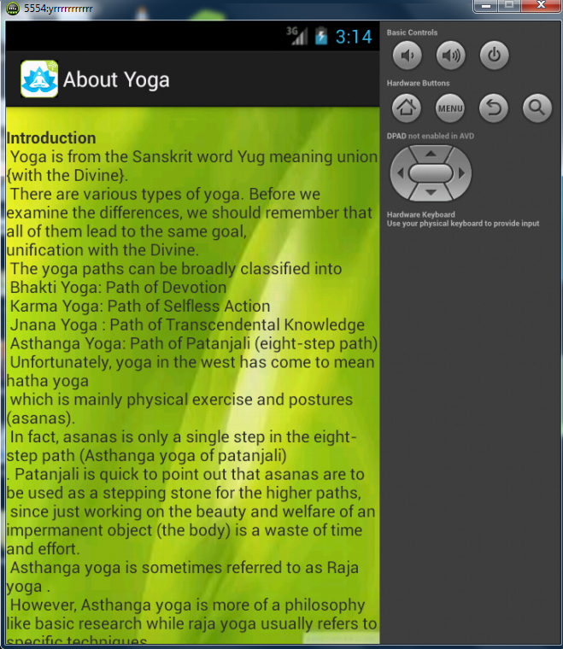

**LIST OF ASANAS**

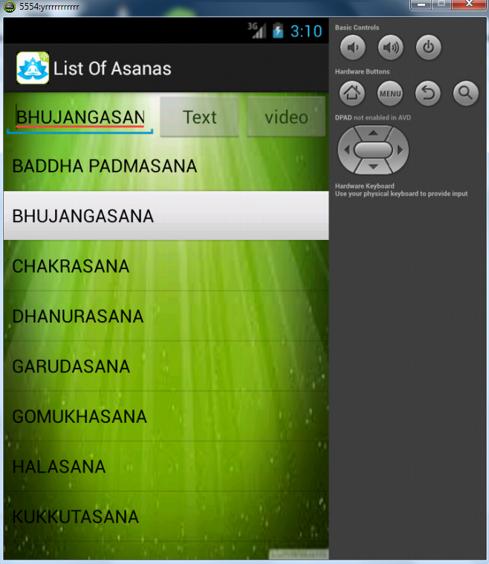

**DISCRIPTION OF ASANA**

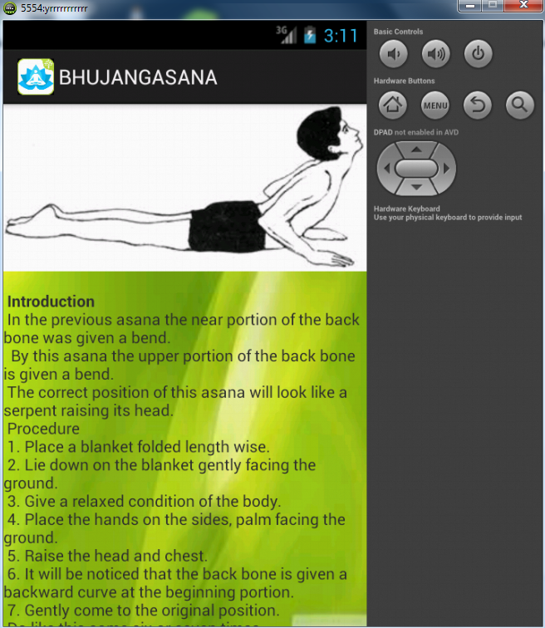

**VIDEO OF ASANA**



**LIST OF DISEASES**

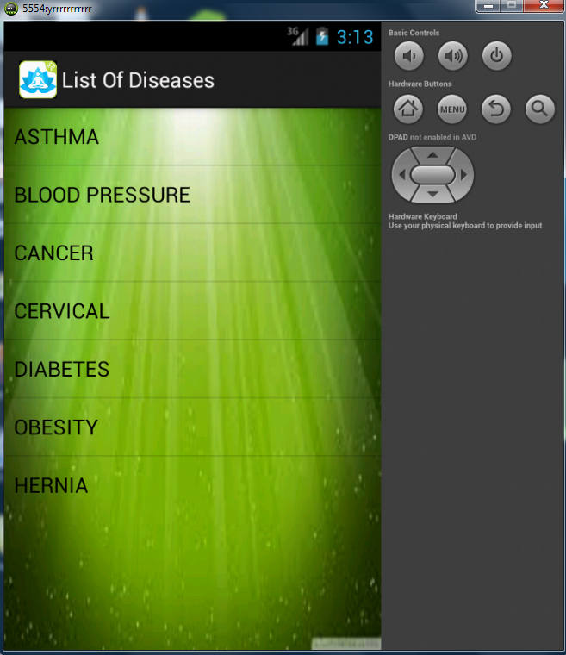

**MENU**

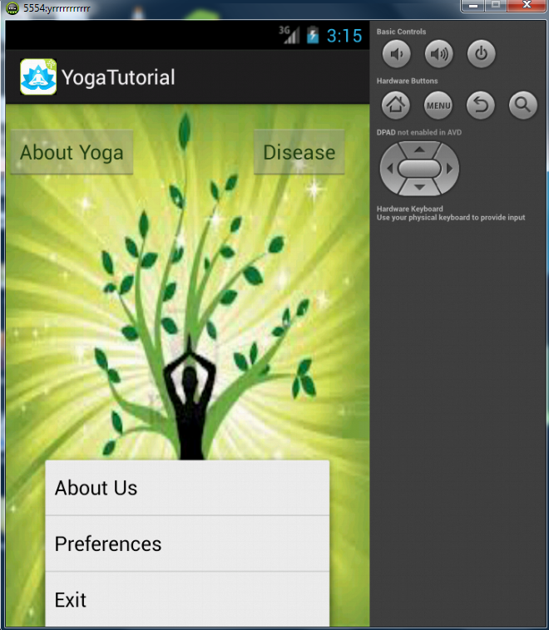

9. Contact (email id ): [shivani.singal129@gmail.com](mailto:shivani.singal129@gmail.com),

snigdha.chauhan.288@gmail.com